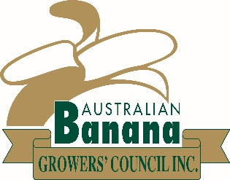

Dear Members,
I would like to thank you for your support in 2016.

ABGC has achieved significant progress in terms of containing the spread of Panama TR4, through growers banding together strongly as an industry.

After lengthy negotiations, ABGC’s purchase of the Tully farm containing the disease was completed with settlement on 24 October.

On settlement, ABGC appointed Phillip Neibling as the farm manager to supervise the destruction and other works that were necessary before the wet season. As you may have seen in a previous e-bulletin, destruction has now been completed. All banana and heliconia plants on the property were stem injected with Roundup as well as Confidor to control beetle borer. There will be further work where regrowth has happened.

Security cameras are now in place, and signage has been erected. Other work such as drainage to prevent water flowing across a public road and the installation of pig-proof fencing is continuing.

The purchase of this property is just part of a multi-pronged strategy. This disease could be elsewhere because it can be present but not show symptoms for five years. As growers, we need to continue to be vigilant in our biosecurity measures. Review your on-farm biosecurity measures, inspect and report plants with Panama symptoms and only use known clean planting material.
On an individual basis, each one of us can contribute to a secure, disease free industry.

On this note I would like to thank Craig and Sue Althaus from Blue Sky Tissue Culture in Tully. Craig and Sue voluntarily withdrew their plants from sale in response to Biosecurity Queensland testing a batch of plants for TR4. After a lengthy wait for all the TR4 diagnostic tests to be completed, the samples were conclusively proven to be clear of the disease. They have now returned to normal operations and growers can be confident that Blue Sky Tissue Culture plants did not and do not have TR4.

Tissue culture plants sourced from registered nurseries are still the best option for clean, TR4-free planting material. When sourcing tissue culture plants, growers should be aware that registered nurseries including Blue Sky Tissue Culture, are their best source of clean planting material.

Looking forward, the government loan that industry received to purchase the Tully farm will start to be repaid once the Plant Health Australia (PHA) levy is increased from 0.0103c/kg to 0.5c/kg. The Australian Government has advised that the increase in the levy will occur on either 1 March or 1 July 2017.

My thanks again for your support in maintaining a thriving industry that rises to the challenges.

Please enjoy a safe and restful Christmas/ New Year period!
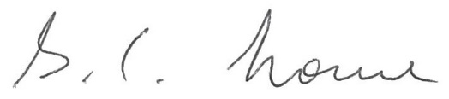
Stephen Lowe
Chair
Australian Banana Growers’ Council

