Insert business logo here

On-Farm Biosecurity Management Plan
Version (insert number) , (insert date)
Farm Name
Address
Contact Details | Phone:  Email:

Contents
How to use this document 3
1. Property information 4
1.1 Details 4
1.2 Land use and overview of farming systems 4
1.3 Farm 5
Figure 1. Farm Map 5
1.4 Packing shed 6
Figure 2. Packing shed layout 6
2. Roles and responsibilities 7
Important Industry Contacts: 7
3. Risk Mitigation 8
3.1 Use of the Land 8
3.2 Restricting access 8
3.3 Zoning 8
3.4 Clean Access Roads and Parking Areas 9
3.5 Wash-down and Decontamination Sites 9
3.6 Tools, Vehicles, Machinery and People Movements 10
3.7 Waste Management 10
3.8 Record Keeping 10
3.9 Fruit Movement 11
3.10 Incident Response 11
3.11 Emergency Access 11
Figure 3. Emergency Access Map 12
4. Processes and procedures that minimise risk of spread of disease from affected land 13
4.1 Destruction Activities and timeframes 13
4.2 Notice of presence of Panama disease tropical race 4 15
4.3 Tracing and Surveillance Activities 16
5. Appendix: Record Keeping Templates 17
5.1. Farm Operational Processes or procedures that minimise biosecurity risks of disease spread. 17
5.2.Planting Material Records 18
5.3. Vehicle and appliance decontamination and movement register 19
5.4. Contractor/ Supplier and Visitor Register 20
5.5. Staff Training Register 21
5.6. Machinery and Farm Vehicle Register 22
5.7 Fruit Movement/Consignment Records and Market Requirements 23
5.8 Sign templates 24

How to use this document

This On-farm Biosecurity Management Plan template is intended for banana growers whose farms have been infested with Panama disease Tropical Race 4. A Biosecurity Management plan is one of the requirements of a notice given by Biosecurity Queensland. The biosecurity plan template can also help other banana growers minimise the risk of introducing or spreading disease on their property. It should be completed in conjunction with the Banana best management practices (BMP) document or with expert advice.
The biosecurity plan template includes guidance on how to mitigate risks posed by various aspects of farming operations. Each aspect has a checklist for the grower to complete for their current farming practices. The checklist in conjuntion with the Biosecurity BMP will identify where the farm is operating at a high standard of biosecurity and will highlight any areas that need to be improved.
For each aspect of banana farming, the grower should provide additional comments on how their farm is mitigating the risk of the disease, or provide a plan (e.g. timeframes, costs, strategy) for implementing improvements.
If you require assistance in putting together your On-farm Biosecurity Management Plan, you should contact Australian Banana Growers’ Council at www.abgc.org.au

1. Property information

1.1 Details
The table below provides the contact details and basic information about the property to which this biosecurity plan relates.
Owner / Occupier
Business name /
ABN / ACN
Lot / Plan
Street Address

Property area (ha)
Tenure

1.2 Land use and overview of farming systems
(Insert land use and provide an overview of your farming systems. For Example. The farm is mostly comprised of banana production but there is a small area under papaya production (2ha))
The total property has an area of (insert area of total property) and (insert area under banana production) is currently under banana production
A farm map is located on page (insert page number of map).

1.3 Farm
(Insert image of farm map/s. If you don’t have a farm map you can easily get a satellite image of your property from Queensland Globe https://qldglobe.information.qld.gov.au/)
Show:
- Banana production area
- Other land use areas
- Location of infected plants
- Packing Shed
- Other sheds (e.g. machinery storage)
- Residences
- Location of pumps/bores
- Roads
- Dedicated Clean Road/s
- Fencing
- Access
- Signage locations

Figure 1. Farm Map

1.4 Packing shed
Insert map/sketch of your packing shed. Below are some tips for what to include on your map:
- It is helpful to include key elements of your shed on the map (e.g. the area where bunches are hung), troughs, pallet stackers, loading docks)
- The zoning of your shed – showing clean and dirty zones
- The location of biosecurity infrastructure (e.g. footwear exchange, footbaths, block walls, physical dividers etc.)
- The direction of movement in your packing shed (e.g. arrows which show the direction of fruit movement from paddock to loading)

Figure 2. Packing shed layout

2. Roles and responsibilities
(Insert name of owner/manager) is responsible for:
- Abiding by the requirements in the Notice of presence of Panama Disease Tropical Race 4, including destruction activities.
- Reporting any significant issues or breaches of the requirements specified in the notice to a Department of Agriculture and Fisheries Inspector.
- Training staff working on (insert name of farm) to respect and ahere to adopted procedures
- Updating this plan as necessary and adherence to this Farm Biosecurity Management Plan.
Department of Agriculture and Fisheries inspectors are responsible for:
- Auditing processes on site of (insert name of farm) and maintaining records of compliance e.g. checklist
- Giving and assessing compliance with Notice of presence of Panama Disease tropical race 4.

Important Industry Contacts:

Australian Banana Growers’ Council
Name | Role description | Contact Details
Dr Rosie Godwin | Research and Development Manager | 3278 4786
Sonia Campbell | Communications Manager | 0428 038 330

Department of Agriculture and Fisheries
Name | Role description | Contact Details
Rhiannon Evans | Panama TR4 Program Leader | 4091 8141
Jodie Bocking | Property Operations and Surveillance Team Manager | 4091 8163  0476 852 415

3. Risk Mitigation
The aims of the risk mitigation steps described in this section are to:
- Minimise the spread of Panama disease tropical race 4 within the property.
- Prevent the spread of Panama disease tropical race 4 to other properties.
- Comply with the processes and procedures described in the notice of presence of Panama disease tropical race 4.
- Enable destruction and maintenance activities to occur while managing the risks posed by the disease.
- Minimise the spread of other biosecurity risks onto or within the property.
The checklists below are adapted from the Banana best management practices guideline and should form a basis for your On-farm biosecurity management plan. You may wish to include more or less practices identified to effectively mitigate the risks of spreading the disease on to or within your property. Please refer to the guideline in the development of your plan.

3.1 Use of the Land
Insert comments: e.g Discuss whether you have only bananas, mixed cropping, cattle etc., and how many parcels of land you might have.

3.2 Restricting access
☐ | Is the property fenced around the boundary, or are there natural barriers in place (for example river frontage) to restrict access to people and machinery?
☐ | Is animal movement restricted (for example feral, native and domestic animals and livestock)?
☐ | Is fencing maintained to a suitable condition to ensure access is restricted?
☐ | Do you have clear signage to direct people (for example visitors or deliveries) to correct access and parking areas?
Insert comments:

3.3 Zoning
☐ | Are zones established to differentiate between clean and dirty areas (A dirty zone would include a banana production area. A clean zone is separate from the banana production area and is free from plant material, soil and mud)?
☐ | Are the zones separated with a clear barrier, such as a fence and/or signage?
Insert comments:

3.4 Clean Access Roads and Parking Areas
☐ | Do you have a dedicated clean access road which has been separated from the banana production area?
☐ | Is it designed to ensure it remains clean by keeping the surface free from soil and plant material?
☐ | Is your clean access road separated with fencing and signage to restrict movement from the banana production zone?
☐ | Are access roads in to clean zones such as packing sheds, residences and associated parking areas maintained as clean?
☐ | Do you ensure your clean access road is free from weeds?
☐ | Do you use chemical methods only to control weeds?
Insert comments on how you achieved your clean access roads and parking areas:

3.5 Wash-down and Decontamination Sites
☐ | Have you established a wash-down and decontamination site for vehicles, machinery and people?
☐ | Are they located at all exit/entry points between clean and dirty zones (except designated clean roads)?
☐ | Are the facilities adequate to complete cleaning to remove soil and plant material?
☐ | Is clean water used for wash-down and decontamination procedures?
☐ | Do you use a recommended product for disinfection against Panama disease?
☐ | Are the facilities regularly maintained?
☐ | Can you control and contain waste water to prevent it from entering all waterways and clean zones?
Insert comments:

3.6 Tools, Vehicles, Machinery and People Movements
☐ | Do you have a cleaning and decontamination procedure for tools, vehicles, machinery and people prior to them exiting a dirty zone?
☐ | Do you limit unnecessary movement of tools, vehicles, machinery and people from the dirty zone?
☐ | Have you considered alternative routes to limit movement between zones?
Insert comments to describe how you manage tools vehicles machinery and people movement:

3.7 Waste Management
☐ | Does all waste material from the banana production area (including leaves, bells, discarded fruit, pseudostem material, bunch stalks, bunch bags, string and soil) remain on the property in a dirty zone?
☐ | Is all other general waste sent to a regulated waste disposal facility?
☐ | Is general waste accessible for collection via a dedicated clean access road and considered in the development of zoning plans?
Insert comments:

3.8 Record Keeping
☐ | Do you have banana planting records?
☐ | Do you have fruit consignment records?
☐ | Do you have records of vehicle and machinery including their movements, cleaning and decontamination?
☐ | Do you have clean access road maintenance records?
☐ | Do you have a visitor and staff register?
☐ | Have your staff been trained or briefed on Panama disease?
☐ | Do you have a farm map showing production areas, roads, boundary fences, dedicated clean access roads, zoning, waste disposal locations and key infrastructure?
☐ | Do you have records of destruction activities undertaken to meet the requirements of the Notice. See section 4.
See Appendices to obtain templates for record keeping.
Insert comments:

3.9 Fruit Movement
☐ | Do you ensure that only the fruit that has had no contact with the ground is harvested?
☐ | Is fruit transported to your packing facility in a clean condition (free from soil and plant material)?
☐ | Are packaging consumables (for example carton boxes, pallets, containers, plastic wrap) free from soil and plant material?
☐ | Do you undertake inspections to ensure your fruit is free from soil and plant material prior to it exiting the property?
Insert comments:

3.10 Incident Response
☐ | Do you have procedures in place in the event of an incident occurring that presents a risk to your on-farm biosecurity?
☐ | Are staff trained in these procedures or know who to notify?
☐ | Have you developed scenarios or identified weaknesses in your biosecurity management procedures?
Insert comments: examples of incidents are any that might compromise the requirements of your biosecurity notice e.g. cattle escape, personel forget change their boots, clean zones become contaminated with soil or plant material etc.

3.11 Emergency Access
The landholder should undertake prior planning with emergency services to develop procedures for emergency access. This includes ambulance, police, fire emergency services, state emergency services, electricity providers, local council.
The property must be listed on any appropriate databases as to the presence of the disease and the need for precautions. This includes any other organisations such as those listed above that make records relating to future emergency access.
In the event of an emergency event, follow on farm biosecurity procedures where practical and notify an inspector appointed under the Biosecurity Act 2014 as soon as possible.
Insert emergency access procedures, including contact details and map showing appropriate entry location for emergency services:

Figure 3. Emergency Access Map
(Insert map)

4. Processes and procedures that minimise risk of spread of disease from affected land
The following requirements are part of a layered hazard control approach to minimise the risk of disease spread from (insert name of farm). These processes and procedures are:

4.1 Destruction Activities and timeframes
A time frame for destruction activities that may be required to be implemented is shown as an example below:
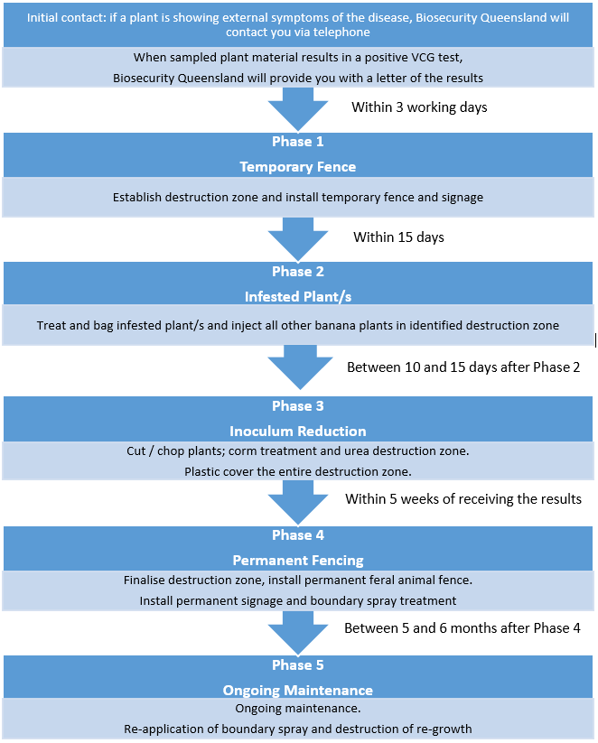
Insert copy of ‘Panama TR4 Program – Record of destruction activities’ for general requirements and phases of destruction for infected and non-infected banana plants. Biosecurity Queensland will provide instructions specific to the affected land subject to a notice.

4.2 Notice of presence of Panama disease tropical race 4

Insert copies all given notices of ‘Presence of Panama disease tropical race 4’. Biosecurity Queensland may amend the notice and provide you with an amended copy. You should keep a record of all notice documentation.

4.3 Tracing and Surveillance Activities

The Panama TR4 Program will conduct tracing activities, including requiring property owners, contractors and/or employees to complete a questionnaire to determine potential pathways for disease spread.
Property owners should keep records of tracing questionnaires and answers.
Insert comments regarding what type of records you are keeping and where records are located.

The Panama TR4 Program will conduct surveillance activities on properties identified as medium or highest at-risk, as detailed in the surveillance frequency letter given by Biosecurity Queensland.

Growers who conduct their own regular surveillance may extend the viability of their farm through early detection and containment of the disease. Staff should be encouraged to check for symptoms of the disease through their day-to-day activities (informal surveillance) or dedicated and planned inspections (formal surveillance).

Property owners should keep records of surveillance activities on their property.

Insert comments regarding what type of records they keep on surveillance e.g. dates, who came, what they found etc.

Insert copies of documentation regarding tracing and surveillance

5. Appendix: Record Keeping Templates

5.1. Farm Operational Processes or procedures that minimise biosecurity risks of disease spread.
Note: In the future, the planned on-line biosecurity BMP will help easily fill these gaps for growers as it would be capable of generating a current farm management plan specific for on-farm biosecurity.
For example – Farm zoning and separation; wash-downs or decon-stations, boot exchanges, shed procedures, farm procedures, fencing, signage, training, record keeping.
1
2
3
4
5
6
7
8
9
10
11
12

5.2.Planting Material Records
Banana planting records that, as a minimum, record the type of planting material used, whether it was completely soil free, details of where and when the material was sourced from and locations where and when the material was planted.
Date planted | Locations & quantity of material planted. e.g. 4000 plants, Block 7 | Type of Planting material (Tissue culture/ bits/suckers) | Source  (where & when was the material sourced?) | Description  (Soil free?/ Healthy?) | Other comments

5.3. Vehicle and appliance decontamination and movement register
This register applies to all vehicles/appliances
- exiting the affected land or
- moving from the dirty zone to the clean zone.
- appliances and any other things leaving the destruction zone.
Decontamination means free of all plant material, soil or anything that may carry TR4 then effectively disinfected using an approved sanitizer.
Date | Time | Vehicle/  Appliance Rego | Vehicle/  Appliance  Details | Movement |  | Decontamination  Tick when completed |  |  | Name and signature of person who conducted the decon/ movement
 |  |  |  | From | To | Plant removal | Detergent | Sanitiser | Name | Signature

5.4. Contractor/ Supplier and Visitor Register
Note - In the BMP it is suggested that you would only need date reason for visit, time in, time out, contact number, and property details of last contact with banana fruit or plants as some of these people shouldn’t be coming on farm so you wouldn’t need vehicle registration and decon etc.
Date | Name |  | Vehicle Rego | Entry Time | Decon on Entry | Vehicle Inspected | Decon on exit | Exit Time | Notes
 | Business | Visitor

5.5. Staff Training Register
Type of Training: ............................................ Trainer: ............................................

Date | Name | Signature |  | Date | Name | Signature

5.6. Machinery and Farm Vehicle Register
Land Parcel:
ZONE  Clean/Dirty etc | Type of machine/ vehicle | Make and model | Registration number | ZONE  Clean/Dirty etc | Type of machine/ vehicle | Make and model | Registration number

5.7 Fruit Movement/Consignment Records and Market Requirements

Insert records or Plant Health Certificates etc.

5.8 Sign templates

Download printable farm gate signage for Panama disease tropical race 4
https://publications.qld.gov.au/dataset/panama-disease-tropical-race-4-grower-kit/resource/9e5728a9-918d-4bb2-9447-01771c4ac5c1
